SAFAL integration with Jenkins

Version Date: 25 May, 2016

Buy-side solutions

https://safal.iam.sungard.com/SAFALWebTool/
Document Title | SAFAL integration with Jenkins
Document ID
Version No.
Document Version History
Version No. | Date | Reason for change | Author | Reviewed by | Approved by
1 |  | Initial draft | Sameer Soundankar | Kamlesh Khatwad

Contents

1 Intended Audience 4
2 Acronyms and Definitions 4
3 Description 4
4 High-level Overview of Jenkins and SAFAL integration 4
5 Steps to configure 5
5.1 Main steps: 5
5.2 Configuration while adding Slave node 6
5.3 Configuration at Slave machine 6
5.3.1 Software to be installed on slave box. 6
5.3.2 Configuration steps at slave machine: 7
5.4 Configuration of Master build job (MasterBuildJob): 7
5.5 Configuration of slave job (SAFAL-SLAVE) 8
6 How to perform sample test 10
6.1 SAMPLE Test Output 10

Intended Audience
Reader should be aware with Jenkins setup and minimal knowledge about SAFAL.

Acronyms and Definitions

Acronym/Term | Definition
Jenkins | Build Management Tool
Master machine | This is a machine on which Jenkins is installed and Product Build takes place
Slave machine | This machine is configured as Jenkins Slave and SAFAL executes test script on this machine.
CI | Continuous integration
SAFAL | SAFAL is an advanced solution for functional and regression test automation. In-house built test automation solution
Test Script | Automation script to be executed once build ready as part of CI

Description
This document provides an overview to configure SAFAL with Jenkins to support Continuous Integration (CI). There are various types of plugins available for Jenkins. Purpose of this document is to provide basic idea of integrating SAFAL with Jenkins. User can refer to specific Jenkins plugin documentation on https://plugins.jenkins.io for more details.

High-level Overview of Jenkins and SAFAL integration

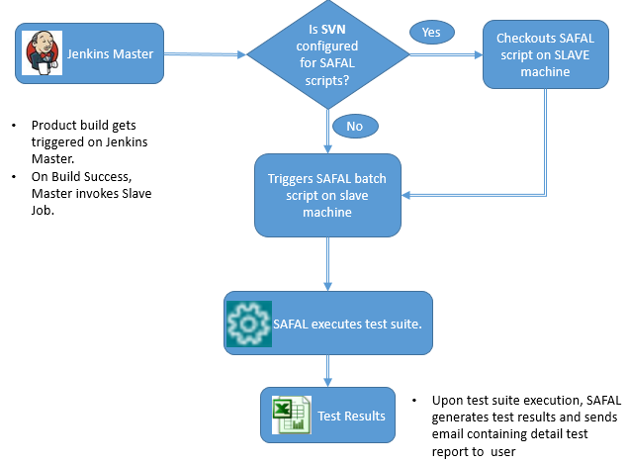

One can execute commands on Slave machine from Jenkins Master with Master/Slave concept of Jenkins. Following steps happens as part of CI

- Product Build gets trigger at Jenkins Master.
- On success of post build, Jenkins Master triggers slave job.
- If sub version for SAFAL script is configured in Slave Job, fetches updated SAFAL scripts from SVN and copies to Slave machine.
- Slave job triggers SAFAL-Cli command on Slave machine.
- SAFAL-Cli launchs SAFAL, which executes test script and generates result in XML format.
- SAFAL-Cli reads XML result and share result (Pass/Fail) through command errorlevel variable which is readable by Jenkins.
- Jenkins Slave returns result to Jenkins Master.
- User can verify execution status on Console Output

Steps to configure

Main steps:

- On Jenkins Master, Create build job of your product on Jenkins master. (E.g. MasterBuildJob). Jenkins Administrator must already create this build job.
- On Jenkins Master, Add Slave node in Jenkins.
- On slave machine, access Jenkins URL of slave node and start Jenkins service.
- On Jenkins Master, create new slave job and configure it to run on slave created in step 2. (E.g. SAFAL-SLAVE)

Configuration while adding Slave node
- On Jenkins Master, access Manage Nodes and click New Node.
- Specify Node name and Select “Dumb Slave” option and click OK.
- Make sure to choose Launch method as Launch slave agents via Java Web Start
- Add JAVA_HOME environment variable, in Node Properties section. Specify JDK path (do not specify JRE path. If your JRE has jps command, then you can specify JRE path)
- Add PATH environment variable. Make sure JDK ‘s bin directory is in PATH environment variable.

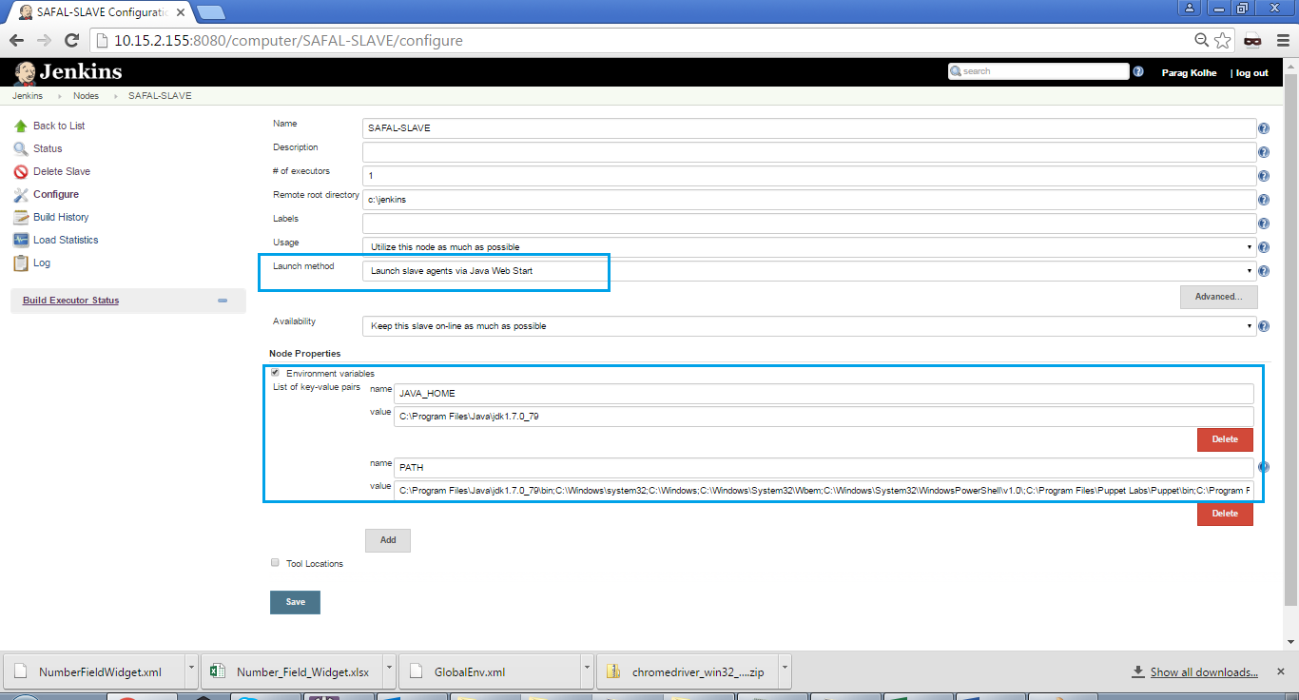
Example of adding slave node

Configuration at Slave machine

Software to be installed on slave box.
- JDK
- SAFAL latest version.

Configuration steps at slave machine:
- Access Jenkins URL for slave node
- Download slave.jar as provided on page in folder (e.g. c:\jenkins)
- Open command prompt and change to directory c:\jenkins
- Execute java –jar command as provided on web page. (See below highlighted section)
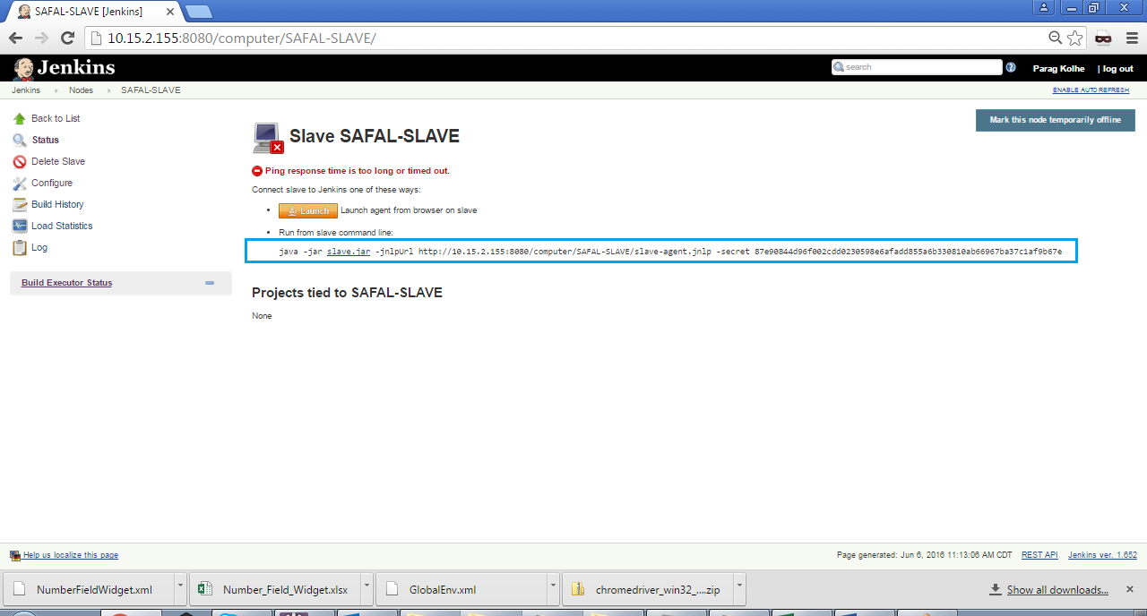

Example of configuration at slave machine

Configuration of Master build job (MasterBuildJob):
- Now in MasterBuildJob, configure Post-build Actions.
- Specify project to build as SAFAL-SLAVE. Check “Trigger only if build succeeds.”
- Save MasterBuildJob.

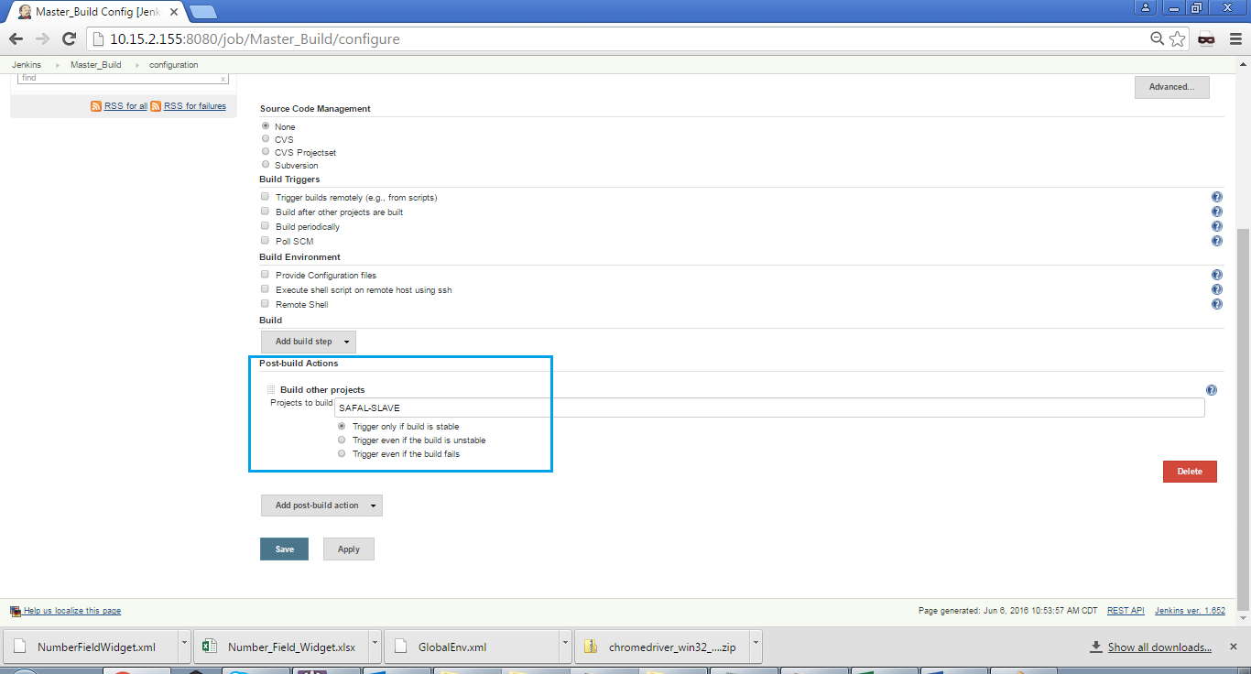

Example of configuring Master Build Job

Configuration of slave job (SAFAL-SLAVE)
- On Jenkins Master, click Slave job (SAFAL-SLAVE) and click “Configure”.
- Check “This build is parameterized”
- Add parameter “Node”
- Select default node as Slave
- In Build Triggers section, check Build after other projects are built
- Specify project name as MasterBuildJob
- In Build section, add build step, execute windows batch command
- Specify SAFAL-Cli command with required parameters. For more information on SAFAL-Cli parameter, please refer to CLI user guide https://safal.fisglobal.com/SAFALWebTool/downloads/SAFAL_CLI_UserGuide.docx

Note: User can either opt to pull script from SVN or similar version control tool on target machine or (s)he can manually copy the script.

- Save SAFAL-SLAVE.
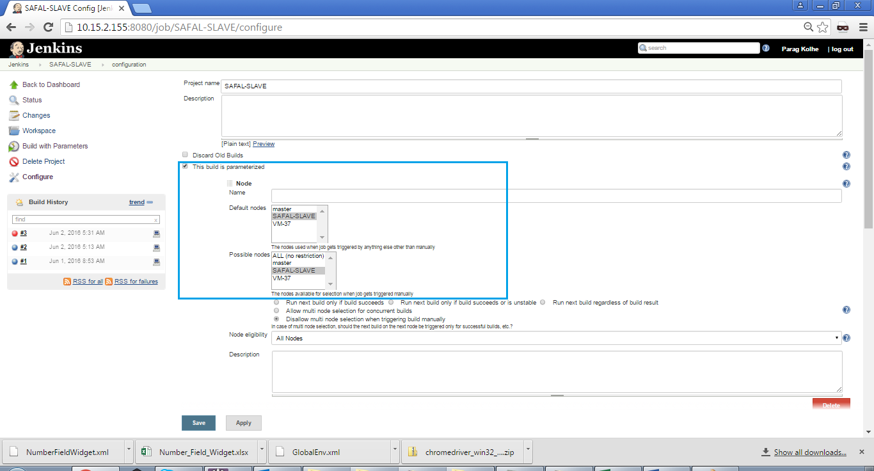

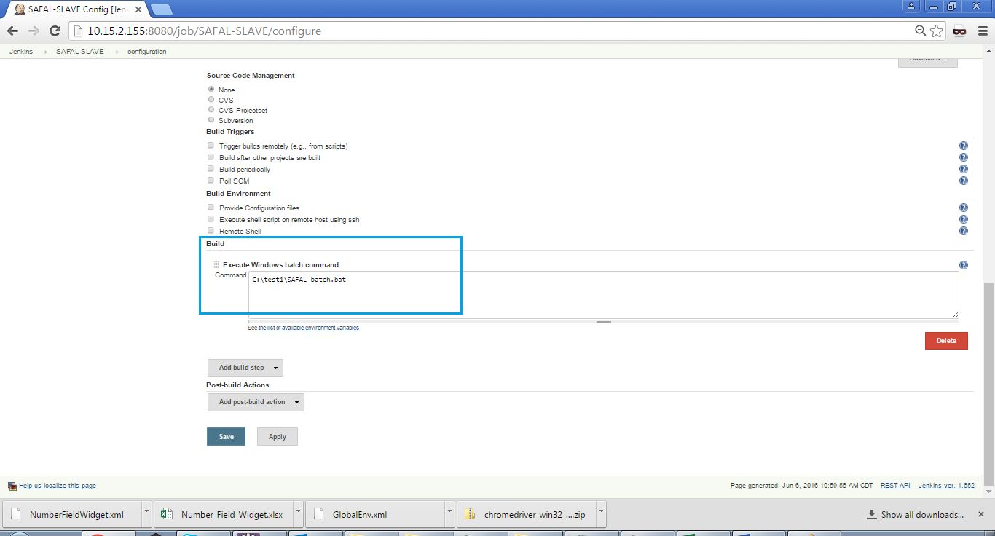
Example of Configuring Slave Job

To check out latest SAFAL script from SVN prior to execution
- In Slave Job configuration page, access Source Code Management section.
- Specify SVN URL and Password.
- Save the Job.

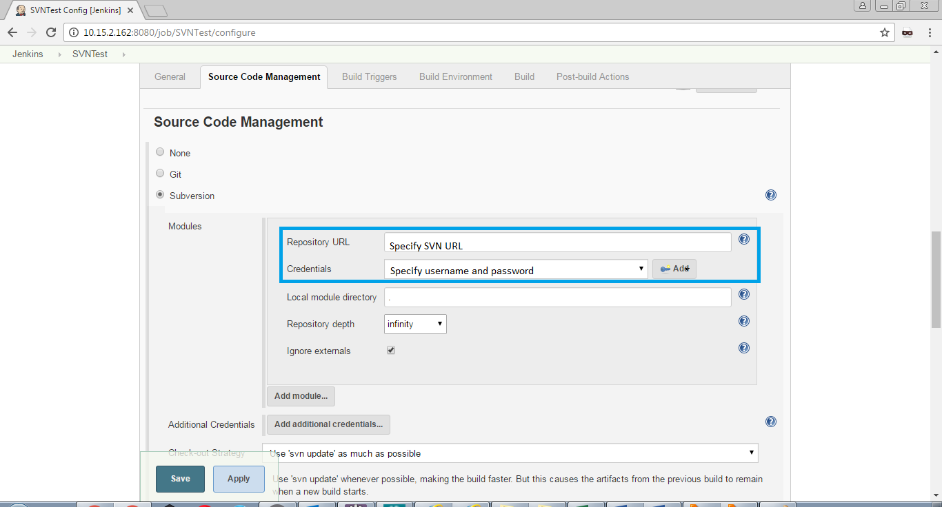

Integrate using Jenkins Pipeline
There is another way to configure SAFAL and Jenkins integration using Jenkins pipeline.

For adding a node, please refer to details of adding slave in previous sections.

For integrating using pipeline, first create pipeline item.

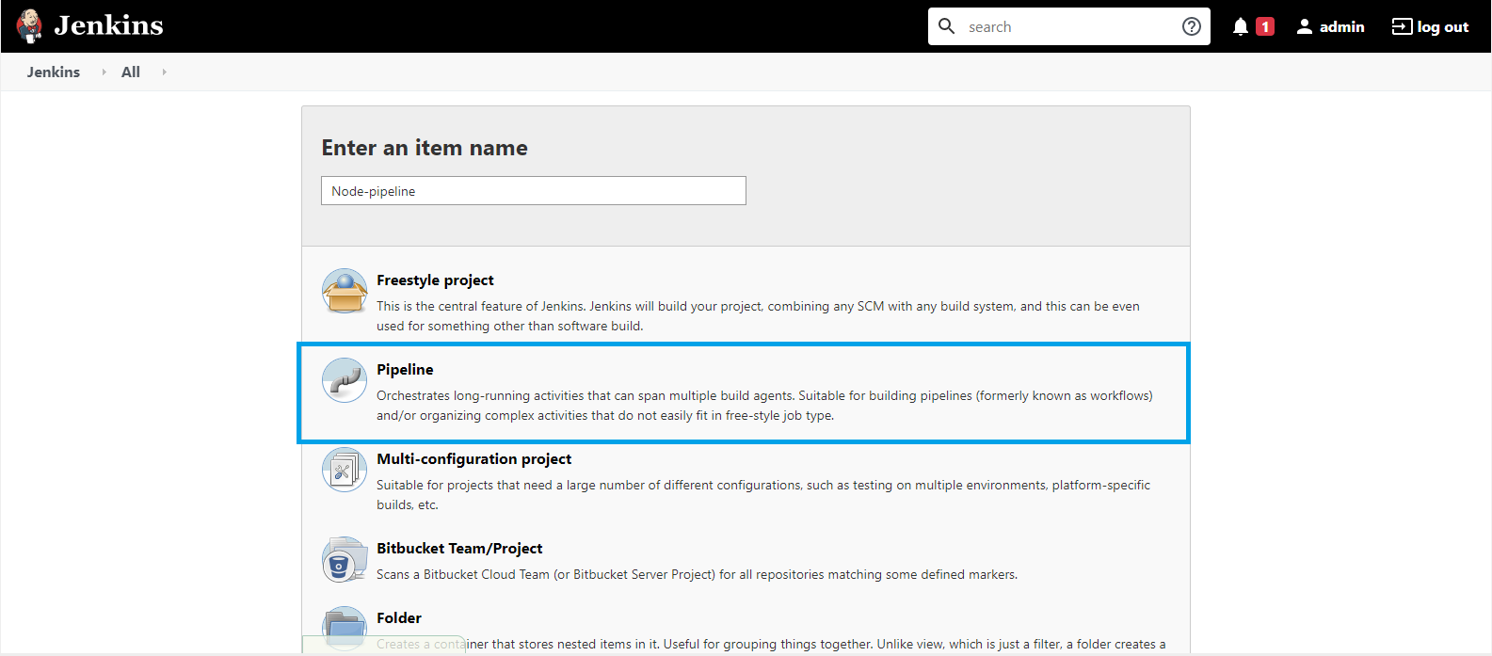

Open newly created pipeline item and click configure.
Navigate to pipeline section and refer to sample pipeline script.

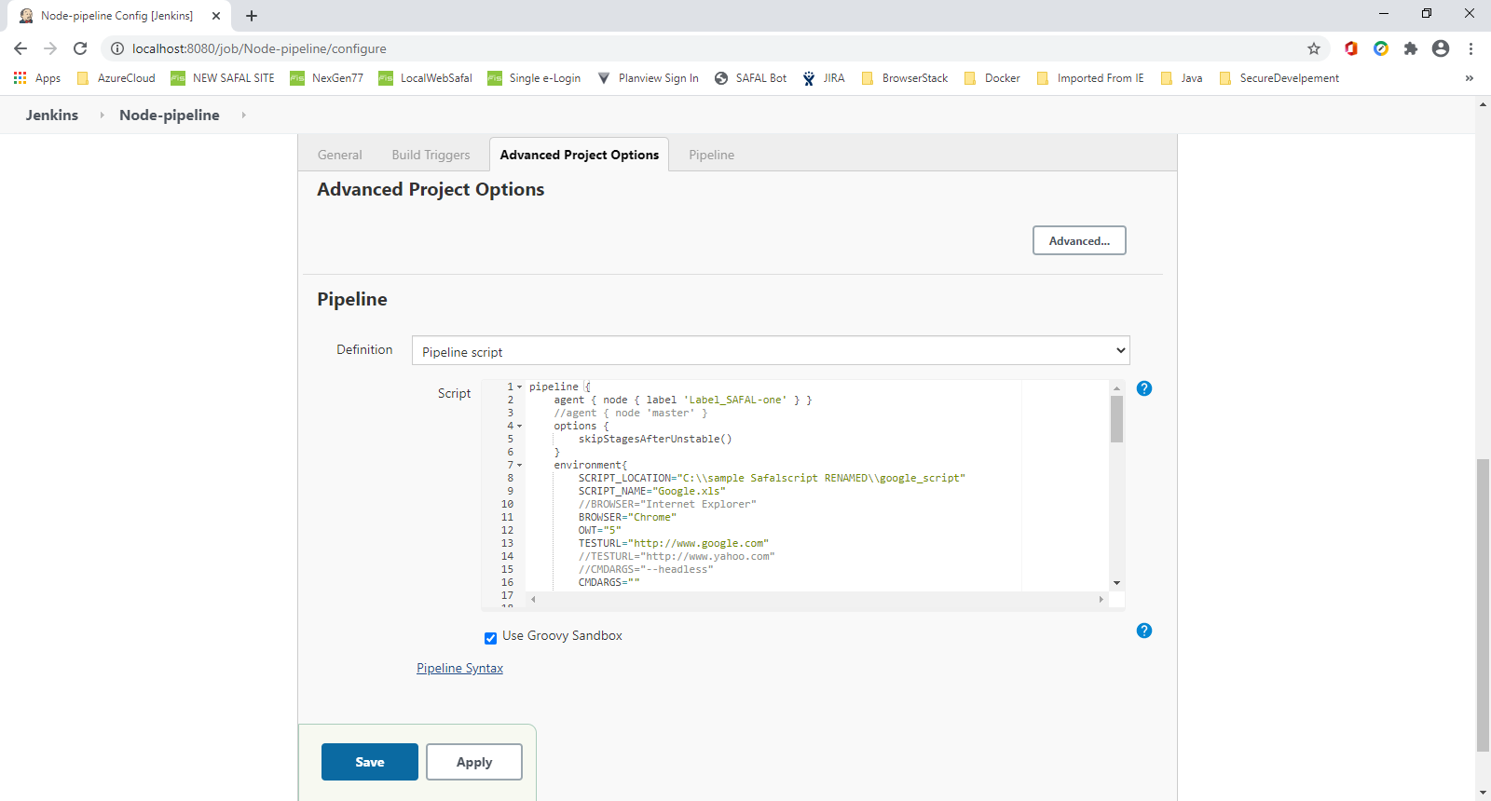

Save the configuration. That’s it!
(Note: pipeline makes a call to a batch file which is present in Node’s workspace folder.
Here is a sample of batch file you can refer.

If you have installed Blue Ocean plugin in Jenkins, after running job you should see scree like following

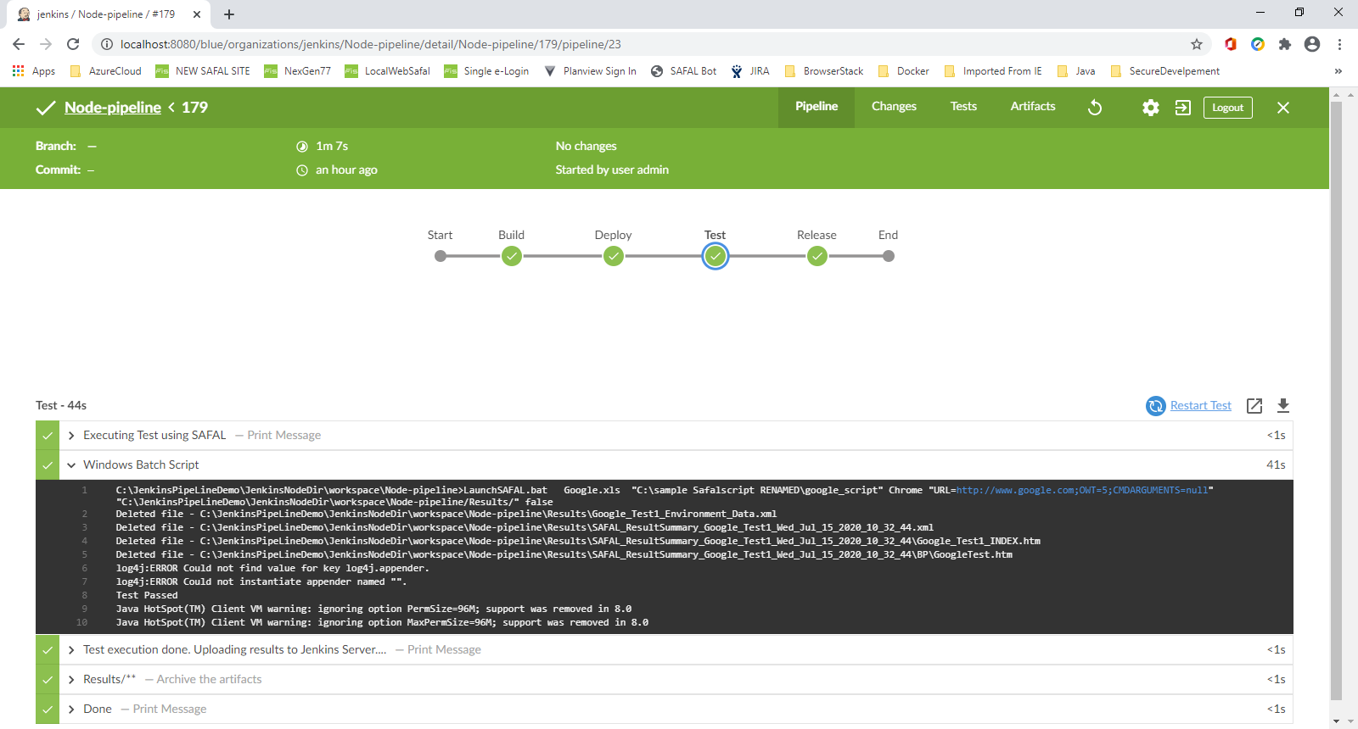

If you have choosed to store test artifacts in pipeline script, you can see test execution results in “Artifacts” section.

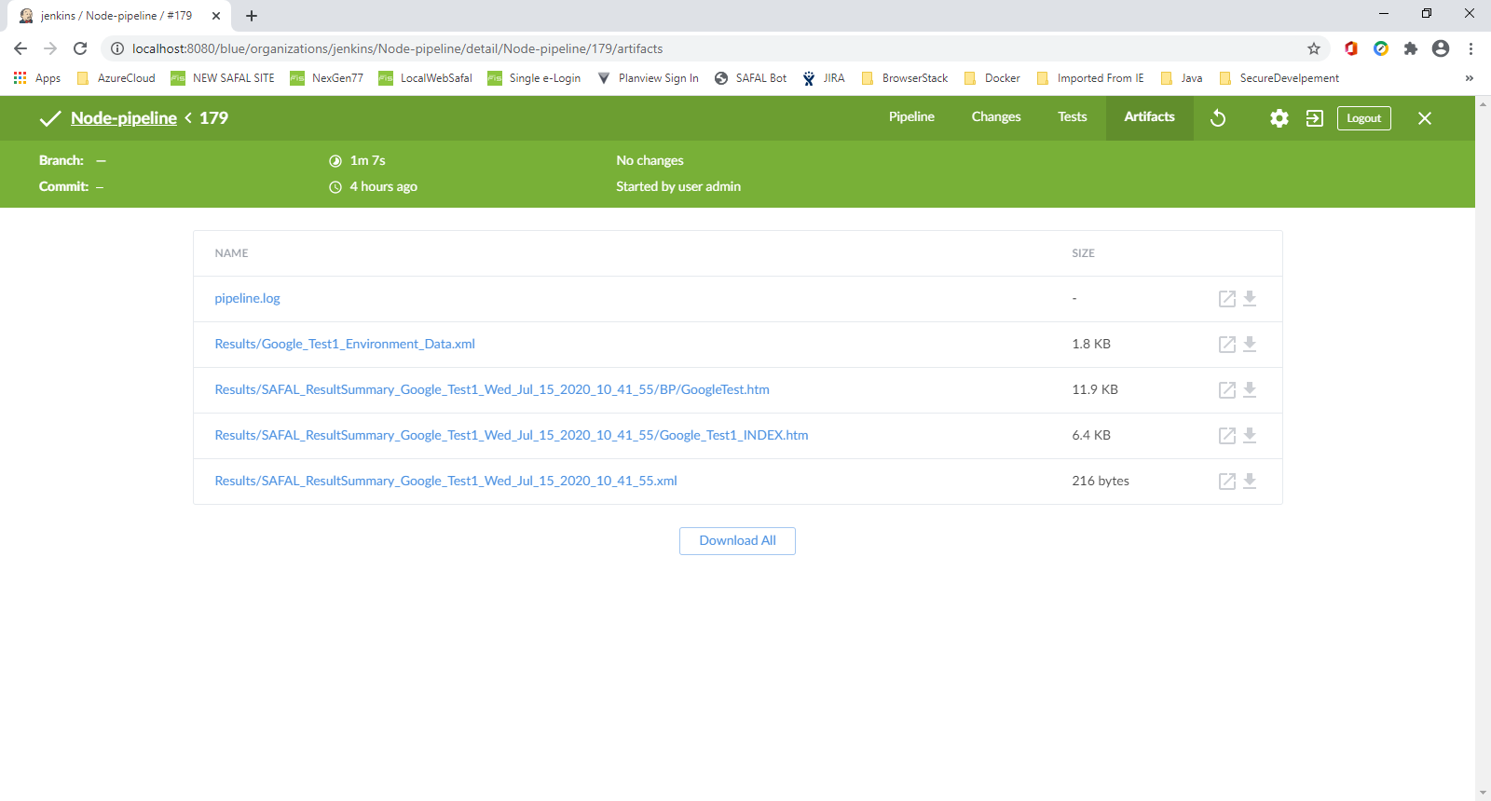

How to perform sample test
- In MasterBuildJob, trigger the build.
- Once build is successful, it will launch SAFAL-SLAVE
- Click SAFAL-SLAVE and monitor Console Output

SAMPLE Test Output
- SAFAL generates result in two ways
  - Overall Test execution result either Pass or Fail in XML format. Based on Test run it will show status in Jenkin for built test run (Pass or Fail)
  - Detail test execution results (HTML or EXCEL or PDF). Detail test result be shared through Auto-Email and distribution list to be configured in SAFAL Auto-Email setting screen.

On Jenkins dashboard, user can see output as follows

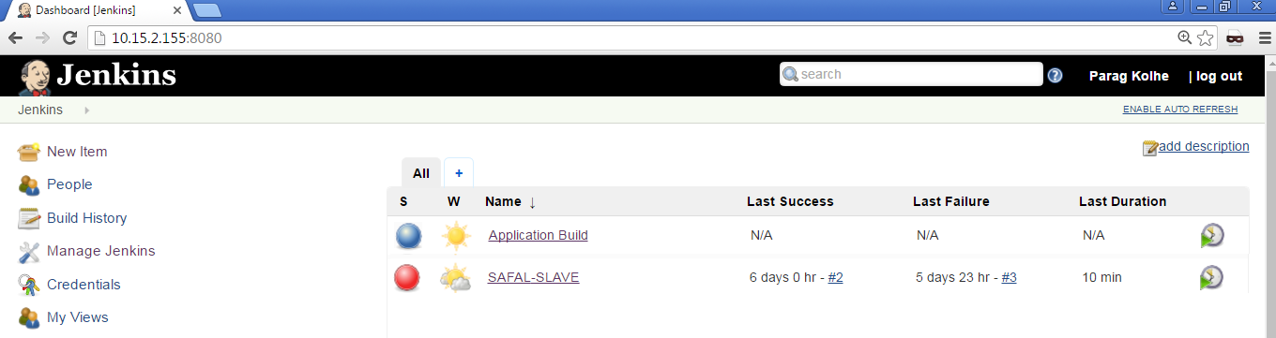

Example of Jenkins dashboard when SAFAL test FAILs

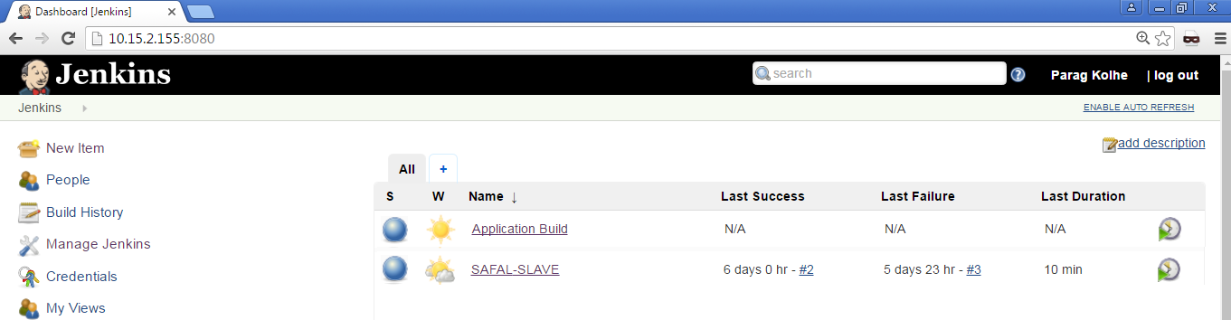

Example of Jenkins dashboard when SAFAL test PASS

Example of sample XML output generated by SAFAL at Slave machine

<xml version="1.0" encoding="UTF-8"?><testsuite errors="0" failures="0" name="testScript" tests="1" time="00:00:06">
<testcase name="Test" status="Pass" time="00:00:06"/>
</testsuite>

End of Document

